H.T No
Regulations:
A17

Sreenidhi Institute of Science and Technology
(An Autonomous Institution)
Code No: 6E517 Date: 07-Dec-2020 (FN)

B.Tech III-Year II-Semester External Examination, Nov/Dec - 2020 (Regular)
THEORY OF COMPUTATION (CSE)

Time: 2 Hours Max.Marks:75

Note: a) No additional answer sheets will be provided.
b) All sub-parts of a question must be answered at one place only, otherwise it will not be valued.
c) Missing data can be assumed suitably.

ANSWER ANY 5 OUT OF 8 QUESTIONS. EACH QUESTION CARRIES 15 MARKS.

1. | a) | Write a short note on Mathematical representation of Finite State Machine. Construct deterministic finite automata to recognize odd number of 1’s and even number of 0’s. | [8M]
 | b) | Construct an NFA accepting binary strings with two consecutive 0’s. | [7M]
2. | a) | Prove that, if L is accepted by an NFA with ε transitions, then L is accepted by an NFA without ε-transitions. | [8M]
 | b) | Convert following NFA to DFA using subset construction method. | [7M]
  δ | 0 | 1
  ->p | {p,r} | {q}
  q | {r,s} | {p}
  *r | {p,s} | {r}
  *s | {q,r} | ----
3. | a) | Obtain a regular expression for the FA shown below  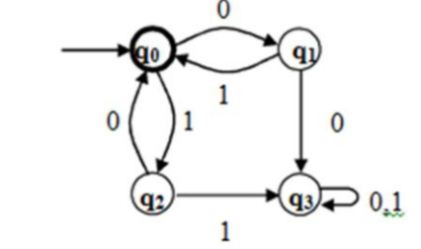 | [8M]
 | b) | S->aB|bA  S->aS|bAA|a  B->bS|aBB|b  Consider the above grammar ,Find left most derivation, rightmost derivation and parse tree for the string aaabbabbba | [7M]
4. | a) | Construct equivalent grammar in Chomsky Normal Form for the grammar  G=( {S,A,B, {a,b}, S->aAbB, A->aA/a, B->bB/b } ,S} | [8M]
 | b) | Find Greibach normal form for the following grammar  S→AA | 1, A→SS |0 | [7M]
5. | a) | Define Turing machine. Explain various types of Turing machines. | [8M]
 | b) | Give short notes on Church’s hypothesis. | [7M]
6. | a) | What is Post Correspondence problem (PCP)? Explain with the help of an example. | [8M]
 | b) | Explain P&NP class of languages. | [7M]
7. | a) | What are the components of Finite state automata? Discuss. | [8M]
 | b) | Give short notes on:  i) DFA ii) NFA iii) Language iv) String | [7M]
8. | a) | Differentiate between NFA with Є moves and NFA without Є moves with examples. | [8M]
 | b) | Design a Moore machine that accepts all strings of 0’s and 1’s treated as binary integer number return a remainder 1 when divided by 3. | [7M]

-- 00 -- 00 –

